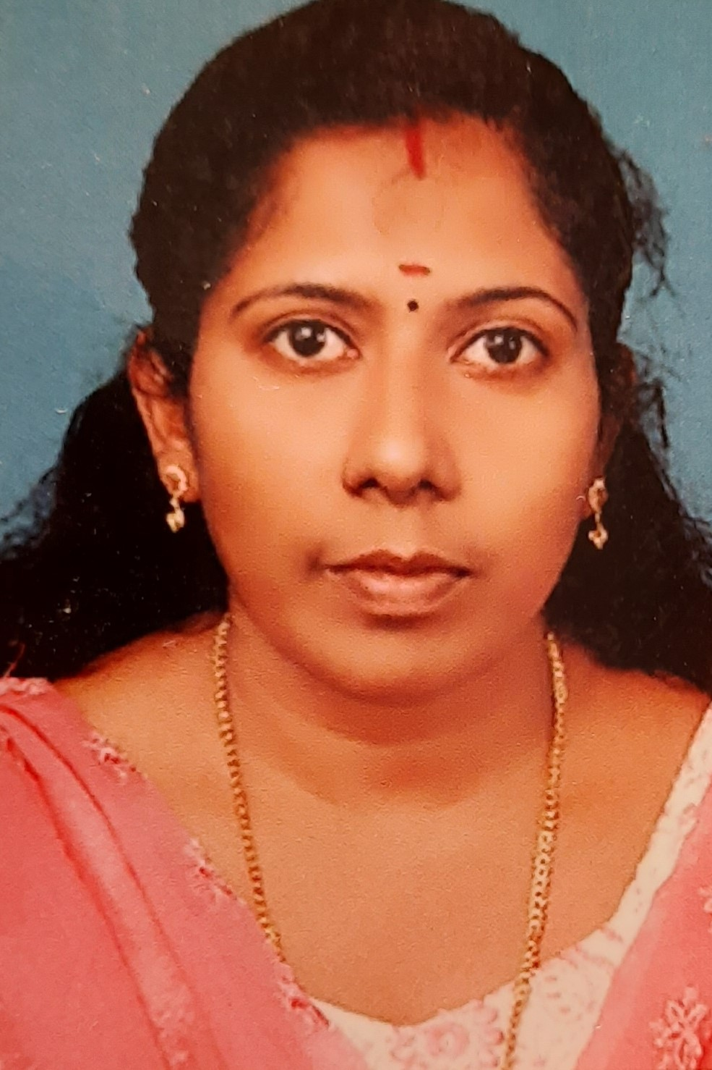t p hoto
Name & Designation DR.SREECHITHRA.V.S.
ASSISTANT PROFESSOR
DEPT. OF HINDI

ADDRESS & EMAIL
SREESYLAM, VATTAKKARIKKAKOM
PANTHALACODE.P.O
Thiruvananthapuram-028

QUALIFICATION
MA, B.Ed, M.Phil, Ph.D, NET.
DATE OF JOINING
17-10-2012
EXPERIENCE IN YEARS
8 yrs 9 months

AREA OF SPECIALIZATION
Hindi Novel

ADMINISTRATIVE DISTINCTION
- Tutor I B A Hindi student 2020
- Member of literary club.

PAPER PRESENTATIONS
1 | NATIONAL SEMINAR | PREMCHAND SAHITYA: EAK PUNARPATH. | 31-07-2018 & 1-8-2018
2 | NATIONAL SEMINAR | SAMAKALIN HINDI SAHITYA :VIVIDH VIMARSH | 26-10-2018 &27-10-2018
3 | INTERNATIONAL SEMINAR | HINDI BHASHA SAHITYA, SINEMA EVAN PATRAKARITA:VAISHVIK DHARATAL PAR. | 30-1-2019 & 31-1-2019
4 | REGIONAL SEMINAR | HINDI VYAKARAN | 15-11-2018
5 | NATIONAL SEMINAR | HINDI KO PRAVASI SAHITYA KI DEN | 17-1-2019
6 | REGIONAL SEMINAR | CINEMA EVAN SAHITYA | 27-3-2019
7 | REGIONAL SEMINAR | KINNAR VIMARSH | 30-11-2017
8 | REGIONAL SEMINAR | VISHVA SAHITYA MEIN MAHILA LEKHAN KI PRAMUKH DHARAEYM. | 31-10-2018
9 | National webinar  (Co-cordinator) | Human compassion in Contemporary Hindi Fiction | 16-12-2020
10 | International webinar  (coordinator) | Cyber Influence in Hindi Short-stories | 25-06-2021
11. | Naional Seminar  (Co-ordinator) | Premchand sahitya kii prasangigatha | 31-7-2023
- 1.Presented a paper in the two day National Seminar on “Contemporary Literature in Comparative Perspective” Organized by Department of Hindi, SNCW, Kollam from 24.02.2023 & 25.02.2023

- 2.conducted. a National seminar on 'premchand Sahitya ki Prasangigkatha' on 31-7-2023.

- 3. Editted a book for I Semester BA 2nd language 'katha sansar'.Dr.Sreechitjra

PARTICIPATION IN SEMINARS/ CONFERENCES/ WORKSHOPS

1 | National webinar | Relevance of Premchand Literature | 31-07-2020
2 | National webinar | Contemporary Hindi Fiction and Female References | 09-11-2020
3 | National webinar | Comparative Literature and Translation | 04-05-2021
4 | National webinar | Evolution of Contemporary Hindi Literature | 28-05-2021
5 | National webinar | Yoga-kabirdas ki drushti mein | 21-06-2021
6 | Workshop (Swayam) | NPTEL and MOOC’S | 26-06-2021
7 | FDP Programme | DIGITAL CONTENT MANAGEMENT ON E-LEARNING | 13TH June to 19TH June 2021 .
8 | National webinar | Writings of Premchand in Today’s Context | 31-07-2021
9 | National seminar | Contemperory Literature in Comparative Perspective | 24th and 25th February 2023

INVITED LECTURES AS RESOURCE PERSON

PUBLICATIONS IN BOOKS OR JOURNALS
- An article published on Manorama Year Book -2021- ‘ BHARATIYA SAHITYATHILE VANITAKAL-2’
- An article published on Sangrathan –Auguest 2020 - ‘पहाड़ पर लालटेन में ग्राम्य जीवन’

- An article published on the book edited by Dr.Remya.G.S.Nair- ‘मोरिशस के प्रेमचंद :आभिमन्यु अनत’
- An article published on the book edited by Dr. Jayasree.A- ‘मैं पायल हूँ’-में त्रिलिंगीय विमर्श’
- Edited a book for I semester 2nd language “katha Sansar”
MEMBERSHIP IN PROFESSIONAL BODIES
OTHER ACHIEVEMENTS

