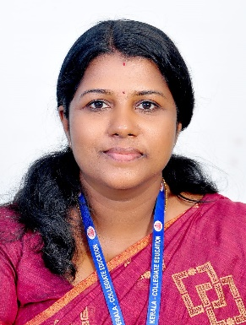

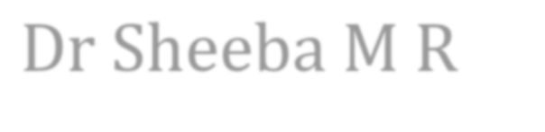
Dr Sheeba M R
Associate Professor of Hindi

ADMINISTRATIVE DISTINCTION
ADDRESS & EMAIL
Mangattu.H Arakuzha P.O Muvattupuzha Ernakulam (Dist) Pin – 686672
sheebashiju8@gmail.com

QUALIFICATION
MA, B Ed, M. Phil, PhD

DATE OF JOINING
13.03.2008

EXERPIENCE IN YEARS
15 years

AREA OF SPECIALIZATION
Hindi Literature

- Member, Admission Committee
- Member, NSQF
- Tutor, IIIBA

PAPER PRESENTATIONS

- Presented a paper in the Three day UGC National Seminar conducted on 14th, 15th, & 16th March 2017 Organized by the Department of Hindi, Sree Sankaracharya Unviersity of Sanskrit, Panmana Campus, Kollam, Kerala.
- Presented a paper for the DCE sponsored Two day National workshop held on 1st & 2nd December 2016 at Govt. College for Women, Thiruvananthapuram.
- Presented a paper in the international seminar on the “Different Aspect of Hindi Literature after 1980’s” organized by the Department of Hindi, S.N. College for women, Kollam on 31 January and 1 February 2019.
- Presented a paper in the 3day International Seminar on "Indian Literature, Language and Mass Media" Organized by the Department of Hindi SNCW Kollam from 20,21 & 22 January 2020
- Presented a Paper in the two day National Seminar, Organized by Department of Hindi, SNC Kollam from 26.10.2018 and 27.10.2018.
- Presented a paper in the two day National Seminar on “Contemporary Literature in Comparative Perspective” Organized by Department of Hindi, SNCW, Kollam from 24.02.2023 & 25.02.2023.

PARTICIPATION IN SEMINARS/ CONFERENCES/ WORKSHOPS

  - Participated in the Three Day National Seminar during 17th to 19th January 2017, Organized by the Department of Hindi, University of Kerala, Kariavattom Campus, Thiruvananthapuram, Kerala.

WEBINAR ATTENDED INTER NATIONAL & NATIONAL
- “Contemporary Discourse and corona period”(SNCW, KOLLAM on 11/6/2020)

- Indian Modernity And Culture: a gender perspective (SNCW , Kollam on 27/7/2020)
- New Century Hindi She Writers - In Diverse Realms ( SNCW KOLLAM, on 21/9/2020)
- Contemporary Hindi Fiction And Female References (SNCW,KOLLAM, on 9/11/2020

PUBLICATIONS IN BOOKS OR JOURNALS
- “Chitra Mudgal Ke Kathasahitya mein Prathirodhiswar”- Jawahar Pustakalay. Sodar bazaar, Mathuro-281001. ISBN: 978-81-8111-389-4
- “Manavadhikar keliye samgharsh : P.O.Box No 203,Nala Sopara” Sangrathan, Thiruvananthapuram, December 2018.
- “Kavya Kaumudi” BA/BSc Syllabus, Editor, Rajpal & Sons. Delhi- 110006, 2021.
- “Hindi Kahani Sahity mein Kinnar Vimarsh” -Sangrathan, Thiruvananthapuram, July 2022

RESEARCH OUTPUT
- Research Guide under the University of Kerala
- Research Scholars: 4
- Chitra. B (PhD Awarded)
- Raji .R
- Udaya Deepthi A S (PhD Awarded)
- Reshma. B

