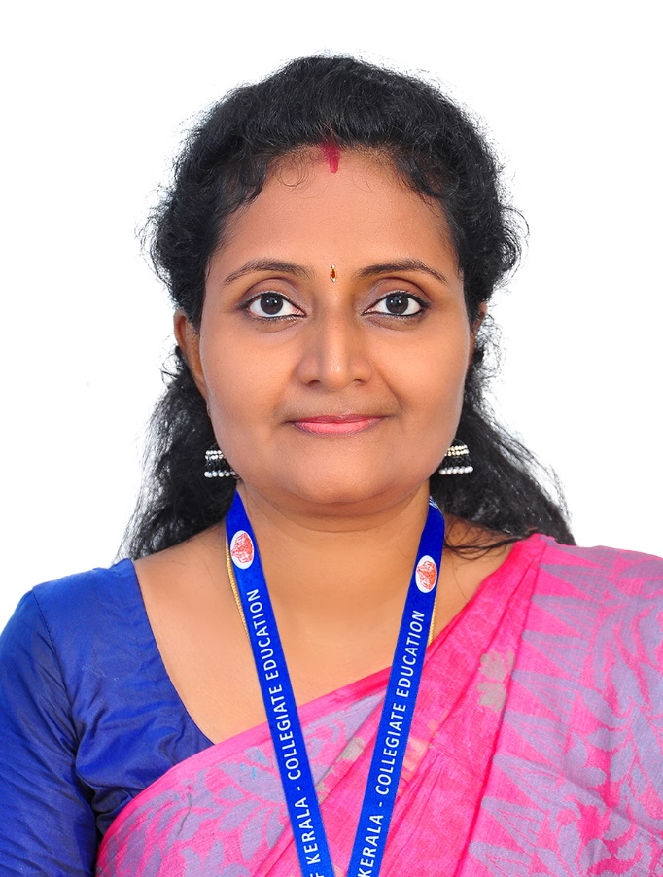
Dr. REMYA A.S.
Assistant Professor of Biochemistry
Department of Biochemistry & Industrial microbiology
Sree Narayana College for Women, Kollam

ADDRESS & EMAIL : Kunnel, Villa No.12, North Brook Villa, Decent Junction, Mughathala P.O., Kollam, Pin: 691577
Mob: 7560806614 /7907624748
e- mail: asremya09@gmail.com

QUALIFICATION : Msc. , Ph.D.

DATE OF JOINING : 07.01.2011

EXPERIENCE IN YEARS : 11 yrs

AREA OF SPECIALIZATION: Phytochemistry

ADMINISTRATIVE DISTINCTION :
- Head of the Department
- Member of Environmental Club
- Chairperson for V semester examinations of Biochemistry (Career Related) in University of Kerala.
- Member- Board of Studies [MG University - Biochemistry]

PRESENTATIONS
- Presented a poster entitled 'Toxicity evaluation and free radical scavenging potential of Oxalis corniculata Linn.' in the International seminar on Recent Biochemical Approaches in Therapeutics [RBAT] organized by Department of Biochemistry, University of Kerala and SBC(I), Kerala Chapter on 23rd-25th of January 2018.

- Presented the paper entitled 'Efficacy of Oxalis corniculata in preventing selenite induced cataract - in vitro" in the three day National seminar organized by the Department of Biochemistry, Government College, Kariavattom, Thiruvananthapuram sponsored by the Department of Collegiate education, Government of Kerala from 30/01/2019 to 01/02/2019.

- Presented a poster entitled 'Prevention of selenite induced cataract in rat pups by Oxalis corniculata in the National seminar on Recent Biochemical Approaches in Therapeutics [RBAT-V] organized by Department of Biochemistry, University of Kerala on 23rd-25th of January 2019.

- Presented the paper entitled ' Effect of Oxalis corniculata in selenite induced cataractogenesis' in the International conference on Advanced Innovation in Science, Engineering and Technology organized by Sree Ayyappa College, Eramallikkara on 8t^{h} to 9th of November 2019.

- Presented a poster entitled Effect of Oxalis corniculata in restoring antioxidant status in rat lens' in the International seminar on Recent Biochemical Approaches in Therapeutics [RBAT-VI] organized by Department of Biochemistry, University of Kerala on 11th -13th of December 2019.

- Presented a paper entitled Attenuation of NF-κB mediated cellular injury and inflammation in rat lens by Oxalis corniculata in the Virtual International conference on Energy, Environment and Health organized by Sree Ayyappa College, Eramallikkara from 15/12/2021 to 31/12/2021

PARTICIPATION IN SEMINARS/ CONFERENCES/ WORKSHOPS
- Attended workshop on outcome based syllabus revision of undergraduate courses in Biochemistry, July 2019 at Department of Biochemistry, University of Kerala, Kariavattom, Trivandrum.
- Participated in the two-day workshop on Research Methodology organized by Kerala University research student's union in association with IQAC, University of Kerala on 29th and 30th May 2015.
- Participated in the UGC sponsored National seminar on Emerging Trends in Materials Science organized by Department of Chemistry, S.N. College for Women from 29th September to 1st October 2014.
- Participated in the International seminar on Recent Biochemical Approaches in Therapeutics [RBAT-II] organized by Department of Biochemistry, University of Kerala on 9th to 11th of December 2015.
- Participated in the National seminar on Recent Biochemical Approaches in Therapeutics [RBAT-III] organized by Department of Biochemistry, University of Kerala on 15th to 17th of Februay 2017.
- Participated in the Workshop on Laboratory Animal Handling organized by Department of Biochemistry, University of Kerala on 19th to 21st of October 2017.
- Participated in the 'Workshop on Popular Science Writing' organized as part of the Science week celebrations 2019 by University of Kerala on 11th and 12th of March 2019.
- Participated in the National Seminar on “Challenges and Changes in AQAR and SSR Preparation” organized by the Internal Quality Assurance Cell (IQAC), Sree Narayana College for Women, Kollam, Kerala on 19 & 20 December 2019.

- Participated in the International Webinar on “Autoimmunity and Antimicrobial Response Factors” organized by Department of Biochemistry and Industrial Microbiology in association with IQAC, Sree Narayana College for Women, Kollam, Kerala on 27 July 2020.

- Participated in the International Webinar on “Role of Gut Microbiome in Human Health” organized by Department of Biochemistry and Industrial Microbiology in association with IQAC, Sree Narayana College for Women, Kollam, Kerala on 21 May 2021.

PUBLICATION
Remya A.S. and Annie Abraham. Effect of Oxalis Corniculata in Selenite Induced Cataractogenesis - in vitro. Journal of Science, Technology and Development 9 [2020] 88 – 92
Remya A.S. and Annie Abraham. Phytochemical profiling of Oxalis cornicula leaf extract. Indian Journal of Applied Research. 11[2021] doi : 10.36106/ijar

FACULTY DEVELOPMENT PROGRAMMES ATTENDED
Underwent the six day Teacher Training Programme from 31st January 2011 to 5th february 2011 conducted by Kerala State IT Mission in connection with the project “Skill Enhancement Computer Training and Women Resource Center in Colleges of Kerala”.
Underwent the UGC - Sponsored Orientaion Programme (IT-Oriented) conducted by the UGC – Academic Staff College, University of Kerala, Kariavattom from 30-04-2014to 27-05-2014

Underwent the UGC - Sponsored Refresher Course (Environmental Sciences - Interdisciplinary) conducted by the UGC – Academic Staff College, University of Kerala, Kariavattom from 02-02-2017 to 22-02-2017.

Underwent the short term Course in Environmental Science conducted by the UGC – Academic Staff College, University of Kerala, Kariavattom from 05/03/2018 to 12-03-2018.

Underwent the UGC - Sponsored short term Course in Disaster management (online) conducted by the UGC – Academic Staff College, University of Kerala, Kariavattom from 19/02/2021 to 25-02-2021.

Participated in workshop on outcome based syllabus revision of UG course in Biochemistry organized by University of Kerala, 27/06/2019 to 03/07/2019 at Department of Biochemistry, University of Kerala, Kariavattom, Trivandrum.

Underwent the short term Course in Disaster Management conducted by the UGC – Academic Staff College, University of Kerala, Kariavattom from 19/02/2021 to 25-02-2021.
Completed online two- week Inter disciplinary Refresher course/FDP in Managing online classes and C-creating MOOC’s organized by Ramanujan College, University of Delhi from 02/06/2021 to 16/06/2021.

