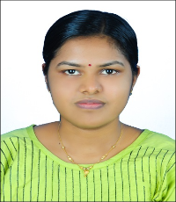
Gowri Praveen
Assistant Professor of English

Insert photo

ADDRESS & EMAIL
Puleeckal
Valiyakulangara Ochira P.O.
Kollam- 690526
gowripraveengp25@gmail.com
QUALIFICATION
Integrated M.A in English Language and Literature
UGC-NET
DATE OF JOINING
29-11-2023

EXPERIENCE IN YEARS

AREA OF SPECIALIZATION
Cultural Studies

ADMINISTRATIVE DISTINCTION

PAPER PRESENTATIONS

PARTICIPATION IN SEMINARS/ CONFERENCES/ WORKSHOPS
- Attended One Week Online Short-term Faculty Training Programme on ‘Hands-on Training on Learning Management System (Moodle- LMS) organized by The Kerala State Higher Education Council from 6th to 12th December 2023
- Completed 16-hour Personality Development Training Programme conducted by Kerala Knowledge Economy Mission from 1st to 16th December 2022

INVITED LECTURES AS RESOURCE PERSON

PUBLICATIONS IN BOOKS OR JOURNALS
- International Journal of Health Sciences (IJHS) Scopus Indexed-(special issue VI 2022),(ISSN-2550-696X) Published a paper titled REPRESENTATION OF DISABILITY AND CHILDHOOD TRAUMA IN WHAT HAPPENED TO YOU AND A HELPING HAND
MEMBERSHIP IN PROFESSIONAL BODIES

OTHER ACHIEVEMENTS

RESEARCH OUTPUT

CITATIONS AND INDEXING, IF ANY
- JOURNAL CITATIONS

- INDEXING (h-INDEX)

